2022 STUDENT POSTER CONTEST

The Arizona Psychological Association and the Arizona Psychological Foundation promote psychological science and practice, which facilitates healing, well-being, and overall mental health literacy for individuals, families, and communities. We are excited to announce our annual student poster contest, to be held at the 2022 annual convention of the Arizona Psychological Association. The poster session will be held on Friday, September 30, in the morning, at the Prescott Resort and Conference Center.

All posters should be prepared in APA format. Potential proposal authors may wish to consider the article “Ten simple rules for a good poster presentation” which is available here: www.ncbi.nlm.nih.gov/pmc/articles/PMC1876493/

Monetary awards will be given for first, second and third place posters. Submissions will be judged by a panel of AzPA members, using an assigned rubric (see below).

Reasons to participate:
- Cash award for first, second and third place presenters ($100, $75 and $50, respectively).
- Build your curriculum vitae.
- Invite email communication regarding your work.
- Great for graduate school or employment applications – demonstrate your academic/ research capabilities!

Rules for Participation:
- Any undergraduate or graduate student, intern or post-doctoral fellow may submit a poster proposal for consideration. It is not necessary to be a member of AzPA.
- Individuals are limited to one submission for consideration.
- Submissions are welcomed from all areas of psychology.
- Proposals may include original empirical studies, program development/evaluation, critical literature review, a meta-analysis, etc. Please keep in mind the scoring rubric (below) when preparing your poster (i.e. a proposal for a study that has no data is unlikely to score well).

Procedures for Submitting Proposals:
- Submit the Poster Proposal cover sheet (see page 2).
- Prepare and submit a 500 word abstract (page 3), 12-point font, double-spaced, detailing the work and the proposed poster in APA format.
- Submit an image of the final poster, not to exceed 40” x 60” in size.
- Submit the consent to publish on our website form (page 4).

Proposals must be received via email by AzPA, no later than 5pm on Friday August 5, 2022. Send materials to azpa@azpa.org.

Winners will be notified by August 22, 2022.

Cover Sheet: 2022 STUDENT POSTER CONTEST

Title of Poster (Must not exceed 10 words.):
_________________________________________________________________________________
_________________________________________________________________________________
II. Principal author:
First name / Last name: _____________________________________________________________
Current education status: ____________________________________________________________
(School/university name & degree program)
Author’s mailing address: ________________________________________________________
Street
________________________________________________________
City/State/Zip
Contact info: Cell: _________________________
Home: ________________________
E-mail: ________________________
Membership status: ___AzPA student member ___Nonmember
Advisor/Instructor/Supervisor’s name: _________________________, email:__________________

III. Coauthors (please list in order, include any obtained degrees):
Coauthor #1: First name/Last name: ____________________________________________________
Coauthor #2: First name/Last name: ____________________________________________________
Coauthor #3: First name/Last name: ____________________________________________________
ABSTRACT
(500 words maximum, typed)

By submitting this proposal, I indicate that his is my original scholarly work.

Printed name: _____________________________________________________________________

Signature: _____________________________________________Date:_______________________

_________________________________________________________________________________

AzPA would like permission to possibly use your photograph, name, and school affiliation to be used in a wide variety of promotional materials including newsletters, flyers, posters, brochures, advertisements, fundraising letters, annual reports, press kits and submissions to journalists, websites, social networking sites and other print and digital communications. We specifically request your permission to publish your poster on the AZPA website, if selected.

______I grant permission _____I decline permission

Student Name: ____________________________________________________________________

Signature: _____________________________________________Date:_______________________

E-mail Address: ___________________________________________________________________

Appendix A: Sample Poster Arrangements
The following two images are sample layouts for a poster presentation. Your poster does not have to appear in the exact layout as the examples. Students who have never presented a poster are encouraged to work with their faculty advisors to ensure submission of professional, scholarly materials.

EXAMPLE #1:
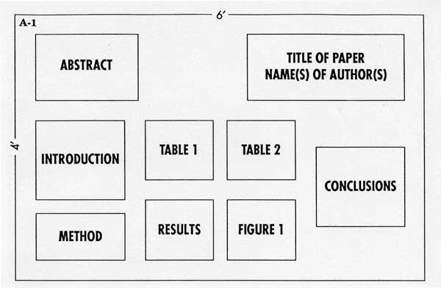
EXAMPLE #2:
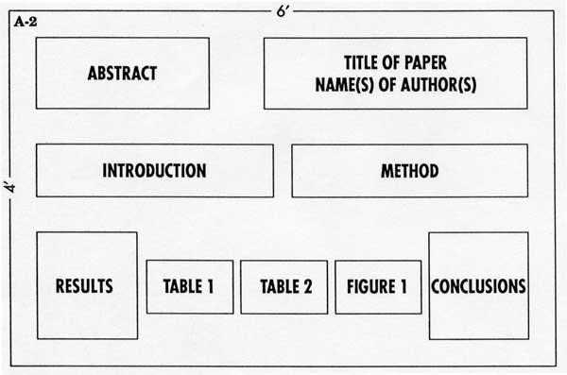
Appendix B: Grading Rubric

Total possible points = 30 Component & Criteria | Does not meet criteria  (0) | Fair  (1) | Good  (3) | Exceptional  (6)
Topic & Purpose | Content is incomplete. Major required topics are lacking or not all included or poorly discussed. | Author describes main idea & purpose of the research or project | …& research or project question(s) | … & reasons behind this research or project.
Scope | The focus is unclear. | Author describes the focus of this research or project | … & where the author concentrates his/her attention | … & foundation for this work.
Method | Section is absent or not relevant to the experiment | Author describe what the he/she did (qualitative project, research project, literature review) | …& the kinds of evidence provided (how it was created, collected, and analyzed | … & how author convinces the reader of the validity of his/her main idea.
Results | Section is absent, more than half incomplete, or not relevant to the experiment | Author describes what he/she learned | … & the major results | … & the consequences of the problem or issue that the author is discussing.
Recommendations | Section is absent or not relevant to the experiment | Author describes solutions to the reader to resolve the problem or issue in the piece | … & recommend action or change based on the research findings or the completed project | … & explain why this matters - Point to at least one significant implication.
Conclusions | Section is absent or not relevant to the experiment | Author describes the cause and effect relationship of the problem/issue | … & the conclusions that he/she draws from the research or project | … & how this work will contribute to the field

